Table of Contents
Professor Teaching Module 1
Recommended Course Placement 1
Total Lesson Time 2
Learning Objectives 2
Instructor Background 2
60-Minute Lesson Plan 3
Part 1 – Introduction to Post-Quantum Cryptography 3
Part 2 – Mathematical Background 3
Part 2A – How LWE Creates a Shared Secret 4
Part 2B – Worked Example 5
Part 2C – Why Doesn’t A Need to Be Square? 6
Part 2D – Encrypting and Decrypting a Message 6
Part 2E – Practical Implications of LWE 7
Part 2F – Understanding LWE Attack Methods 8
Part 3 – SageMath 10
Part 3A – Demonstration 10
Part 3B – Understanding Graphs 14
Part 5 – Student Worksheet Activity 15
Part 6 – Guided Discussion 16
Expected Student Takeaways 16

Professor Teaching Module
Learning With Errors (LWE) Visualization Lab

Recommended Course Placement
This lesson is intended as an introduction to Learning With Errors (LWE) and post-quantum cryptography. It can be incorporated into several undergraduate mathematics and computer science courses including:
- Abstract Algebra
- Number Theory
- Linear Algebra
- Introduction to Cryptography
- Computer Security
- Cybersecurity Fundamentals
- Programming with SageMath
- Mathematical Computing
The lesson is designed as a single 60-minute classroom activity that combines mathematical concepts, programming, and visualization to introduce students to the foundations of post-quantum cryptography.

Total Lesson Time
60 Minutes

Learning Objectives
At the end of the lesson students should be able to:
- Explain the mathematical components of the Learning With Errors (LWE) problem.
- Observe how random error changes a system of modular linear equations.
- Interpret graphical representations of clean and noisy LWE outputs.
- Explain why controlled random error increases computational difficulty.

Instructor Background
Before teaching this lesson, the instructor should be familiar with the basic concepts of post-quantum cryptography and the role of Learning With Errors (LWE) within lattice-based cryptography.
Key concepts include:
- Learning With Errors (LWE) is one of the mathematical foundations of modern lattice-based post-quantum cryptography.
- Unlike traditional public-key cryptosystems like RSA and Elliptic Curve Cryptography (ECC), which rely on factorization and discrete logarithms, LWE is based on systems of linear equations with small random errors added to them.
- These small random errors make recovering the hidden secret computationally difficult which still allowing legitimate users to establish the same shared secret.
- LWE forms the mathematical basis for many modern post-quantum cryptographic systems, including those related to ML-KEM (formerly CRYSTALS-Kyber).
This lesson simplifies visualization of the LWE problem and is intended to build conceptual understanding rather than implement a production cryptographic protocol. Students are expected to understand the role of matrices, vectors, modular arithmetic, and random error in LWE, but they are not expected to learn the complete implementation details of standardized post-quantum cryptographic algorithms.
The primary instructional goal is to help students understand why adding small amounts of random error dramatically increases the difficulty of recovering a secret while still slowing authorized users to communicate securely.

60-Minute Lesson Plan

Part 1 – Introduction to Post-Quantum Cryptography

Instructor Goals
Begin by explaining why new cryptographic methods are needed.

Discuss
- Many of today’s public-key encryption methods, like RSA and ECC, are widely used to protect digital communication.
- RSA is based on the difficulty of factoring very large numbers.
- ECC is based on the difficulty of solving the Elliptic Curve Discrete Logarithm Problem.
- Powerful quantum computers could one day solve these problems much faster than today’s computers, making RSA and ECC vulnerable.
- Post-quantum cryptography is the study of encryption methods designed to remain secure even against future quantum computers.
- One of the most promising approaches to post-quantum cryptography is lattice-based cryptography.
- Learning With Errors (LWE) is one of the main mathematical problems that forms the foundation of many lattice-based cryptographic systems.

Transition
Explain that the goal is not to implement a complete encryption algorithm. Instead, explore the mathematics behind Learning With Errors and discover how adding small amounts of random error makes it much more difficult to recover a secret. This mathematical idea is one of the reasons LWE has become an important foundation for modern post-quantum cryptography.

Part 2 – Mathematical Background
Write on board.
$$b=A∙s+e \left(mod q\right)$$
Then compare with
$$b=A∙s \left(mod q\right)$$
Explain
A is publicly known.
s is the hidden secret.
e is a small random error.
b: becomes the published output.
q determines the modulus used through the calculations.
- Without error, the equations resemble ordinary modular linear algebra.
- With error, every equation changes slightly.
- The equations still look similar, but they are no longer exact.

Part 2A – How LWE Creates a Shared Secret
After understanding the mathematical components of LWE, the next step is to understanding how two people can establish the same secret key without ever sending that key across the network.
Suppose Alice wants to communicate securely with Bob. Both users first agree on a public matrix A [n x m], which anyone, including an attacker, can see.
Alice randomly generates:
- $s_{a}$ – Her secret vector [1 x m]
- $e_{1}$ – A small random error vector
She computes her public value using:
$$b_{a}=A∙s_{a}+e_{1}$$
Alice sends only A and $b_{a}$ to Bob. Her secret vector is never transmitted.
Bob independently generates his own private values:
- $s_{b}$ – His secret vector [n x 1]
- $e_{2}$ – Another small random error vector
Bob computes:
$$b_{b}=A∙s_{b}+e_{2}$$
and sends $b_{b}$ back to Alice
Neither Alice nor Bob ever shares their secret vectors. Instead, each uses their own secret information together with received public information to compute the same shared secret.
Bob computes
$$K_{b}={b_{a}}^{T}∙s_{b}$$
Whilst Alice competes
$$K_{a}={b_{b}}^{T}∙s_{a}$$
Although the calculations appear different, they both simplify to approximately the same value,
$${s_{a}}^{T}∙A∙s_{b}$$
Although the calculations appear different, both users get nearly same shared value. An error correction step will remove the small differences caused by the error vectors, allowing Alice and Bob to establish the exact same cryptographic key.

Part 2B – Worked Example
The previous section explained mathematics using variables. The following example uses simple numbers to demonstrate how the process works.
Suppose Alice and Bob agree on the public matrix:
$$A=\left[\begin{matrix}2 & 1 \\ 3 & 4\end{matrix}\right]$$
Alice randomly chooses
$$s_{a}=\left[\begin{matrix}5 & 2\end{matrix}\right]$$
And computes
$$b_{a}=\left[\begin{matrix}2 & 1 \\ 3 & 4\end{matrix}\right]∙\left[\begin{matrix}5 & 2\end{matrix}\right]$$
Which produces
$$b_{a}={\left[\begin{matrix}12 & 23\end{matrix}\right]}^{T}$$
(For simplicity, the error vector is ignored in this example)
Bob randomly chooses
$$s_{b}=\left[\begin{matrix}4 & 1\end{matrix}\right]$$
Which produces
$$b_{b}={\left[\begin{matrix}9 & 16\end{matrix}\right]}^{T}$$
Bob then computes his shared secret using
$$K_{b}={\left[\begin{matrix}12 & 23\end{matrix}\right]}^{T}∙\left[\begin{matrix}4 & 1\end{matrix}\right]$$
While Alice computes
$$K_{a}={\left[\begin{matrix}9 & 16\end{matrix}\right]}^{T}∙\left[\begin{matrix}12 & 23\end{matrix}\right]$$
Both users obtain the same shared value even though they never exchanged their secret vectors. This example shows the central idea behind LWE: both users independently compute the same shared secret without revealing their private information.

Part 2C – Why Doesn’t A Need to Be Square?
Many students assume that the matric A must be square so that it can be inverted during decryption. However, LWE does not recover the secret by computing $A^{-1}$.
Suppose the secret vector contains 4 values. Instead of creating only 4 equations, Alice may generate 20 public equations. This produces a public matrix with dimensions [20 x 4].
This means there are 20 equations involving the same 4 unknown values.
The 20 rows are called samples. There are not 20 different encrypted messages. Instead, there are 20 noisy equations that all describe the same secret vector.
Although this matrix is not square and cannot be inverted, that does not affect the protocol since Bob never attempts to recover Alice’s secret vector. Instead, Bob generates his own secret vector, computes his own public value, and independently calculates the shared key.
Since neither user solves the other secret, matric inversion is never needed. In practice, modern LWE systems improve security while still allowing legitimate users to establish the same shared secret.

Part 2D – Encrypting and Decrypting a Message
The LWE key exchange does not directly encrypt a message. Instead, it allows Alice and Bob to create the same shared secret key.
Suppose Alice wants to send Bob the message:
“Meet me at the library at 3:00 PM.”
After performing the LWE key exchange, both Alice and Bob have independently computed the same shared key (K) without ever sending that key across the network.
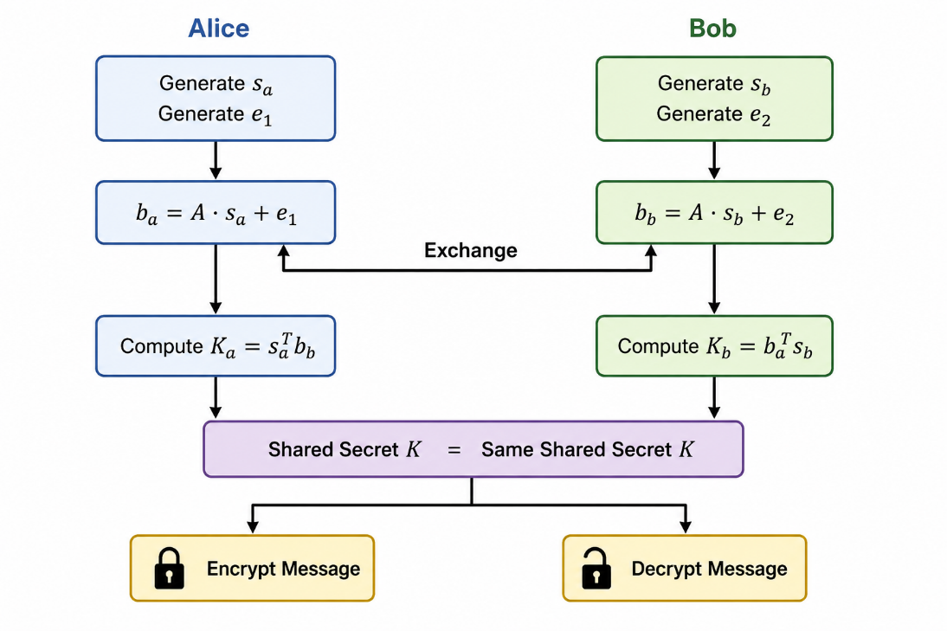
Once Alice and Bob have independently computed the same shared key K, Alice uses that key with a symmetric encryption algorithm, such as AES, to encrypt her message.
$$Ciphertext = Encryt(Message, K)$$
Alice sends only the encrypted ciphertext to Bob.
Since Bob has already computed the same shared key K, he decrypts the message using
$$Message = Decrypt(Ciphertext, K)$$
The Learning With Errors protocol establishes the shared key, while the symmetric encryption algorithm uses that key to securely encrypt and decrypt the actual message.

Part 2E – Practical Implications of LWE
Learning With Errors is more than just a mathematical problem. It provides one of the foundations of modern post-quantum cryptography.
The shared secret established through LWE can be used to securely transmit messages, software updates, financial transactions, medical records, military communications, and other sensitive information.
Unlike RSA and Elliptic Curve Cryptography, whose security depends on mathematical problems that may be solved efficiently by future quantum computers, LWE relies on lattice problems that are currently believed to be difficult for both classical and known quantum algorithms.
Because of this, many modern post-quantum cryptographic systems are based on mathematical ideas closely related to Learning With Errors.

Part 2F – Understanding LWE Attack Methods
Goal: Introduce the different methods used to recover the secret vector in an LWE system and explain why some attacks succeed while others fail.
The SageMath program compares several simplified attack strategies and reports which one recovers the secret most efficiently. This allows students to compare different approaches while recognizing that only simplified versions of these attacks are implemented for instructional purposes.

Attack 1 – Linear Algebra
Mathematical Idea: If there was no error and the matrix is square and invertible,
$$b=As$$
Can be solved using.
$$s=A^{-1}b$$
This method generally does not work for Learning with Errors.
Since A is not a square matrix in the demo, it does not have a standard matrix inverse. Therefore, the secret vector cannot be recovered by computing $A^{-1}b$. Even if A were square and invertible, the additional error vector would still prevent exact recovery.
$$b=As+e$$
contains the error vector $e$
Applying matrix inversion gives us.
$$A^{-1}b=A^{-1}(As+e)$$
$$A^{-1}b = s+A^{-1}e$$
Which is not the original secret since the error term is still there.

Attack 2 – Brute Force
Mathematical Idea: Instead of solving directly, brute force guesses every possible secret vector.
For every candidate,
$$\hat{s},$$
The attacker computed,
$$A\hat{s} (mod q)$$
And compares the result with the public vector.
If,
$$b - A\hat{s}$$
produces only small errors, then guess is considered a secret.

Attack 3 – Lattice Reduction (LLL/BKZ)
Mathematical Idea: Instead of testing every possible secret, the equations are transformed into a lattice. A lattice is a regular arrangement of vectors in multidimensional space. The attacker searches for a short vector corresponding to the hidden error and secret.
Rather than computing.
$$A^{-1}b,$$
Lattice attack attempts to solve an optimization problem:
Find the shortest lattice vector that satisfies the public equation.
Algorithms commonly used include:
- LLL (Lenstra-Lenstra-Lovasz)
- BLZ (Block Korkine-Zolotarev)

Attack 4 – Blum-Kalai-Wasserman (BKW)
Mathematical Idea: The BKW algorithm does not search every secret. Instead, it repeatedly combines equations to eliminate variables.
For example,
$$a_{1}∙s+e_{1}=b_{1} \\ a_{2}∙s+e_{2}=b_{2}$$Subtracting one equation from another produces
$$(a_{1}-a_{2})s + (e_{1}- e_{2}) = b_{1 }- b_{2}$$
By repeatedly combining equations, variables can gradually be eliminated. The remaining system becomes easier to solve, although the accumulated error grows larger after each elimination.

Attack 5 – Hybrid Attacks
Mathematical Idea: Hybrid attacks combine several techniques. Instead of solving the entire secret simultaneously, the attacker first guesses part of the secret,
$$s=\left(s_{1},s_{2}\right)$$
Using brute force. The remaining unknown values are then recovered using another technique such as lattice reduction. By reducing the number of values that must be guessed directly, hybrid attacks are often significantly faster than pure brute-force search.

Comparing Attack Methods
Attack | Main Idea | Works If A is Not Square | Effective on Real LWE
Linear Algebra (matrix inversion) | Compute $A^{-1}b$ | No | Not usually since matrix A is almost never square
Brute Force | Guess every secret | Yes | Only for toy examples
Lattice Reduction LLL/BKZ | Search for lattice vectors | Yes | Yes
BKW | Combine equations to eliminate variables | Yes | Yes
Hybrid | Combine brute force with lattice reduction | Yes | Yes

Part 3 – SageMath
Before running the simulation, students should understand the following key ideas:
- A is a public and can be seen by everyone.
- Each user generates their own private secret vector.
- Secret vectors are never transmitted across the network.
- Alice and Bob independently compute the same shared key.
- Small random errors hide secret while still allowing legitimate users to establish the same key.
- Increasing the amount of error generally increases security but may eventually reduce reliability.
The SageMath demonstration allows students to visualize these concepts and observe how changing different parameters affects the behavior and security of the LWE system.

Part 3A – Demonstration
Run the program using the default parameters.
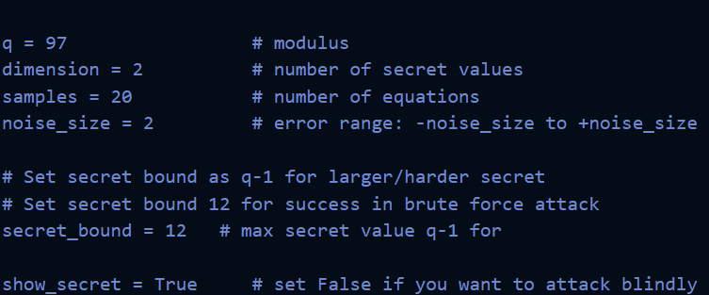

Public Information
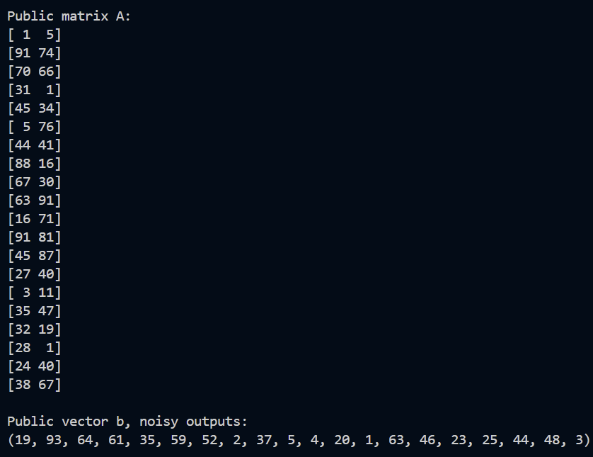
Explain:
- The public matrix contains the coefficients used to generate each equation.
- The public vector contains the published outputs.
- In real cryptographic systems these values would be publicly available.
- Students should recognize that the secret is not directly visible in either of these objects.

Student Output Table
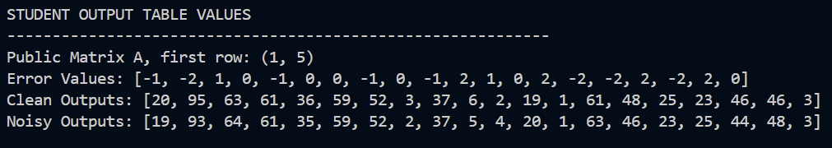
Clean Outputs:
These are calculated before adding random error vector.
They represent:
$$A∙s \left(mod q\right)$$
Noisy Outputs:
These are calculated after adding error vector.
They represent:
$$A∙s+e \left(mod q\right)$$
Compare the values.
Clean | Noisy
7 | 5
23 | 24
92 | 90
Explain:
- Some outputs increase.
- Some decrease.
- Some remain unchanged since the randomly generated error happened to be zero.
- The output remains close to one another since the error is intentionally small.
This demonstrates that the system is perturbed, not destroyed.

Secret Information

Explain:
The secret is only displayed for analysis and understanding so the students can verify that the demonstration is functioning correctly.
In practice, this value would never be public.

Parameter Analysis
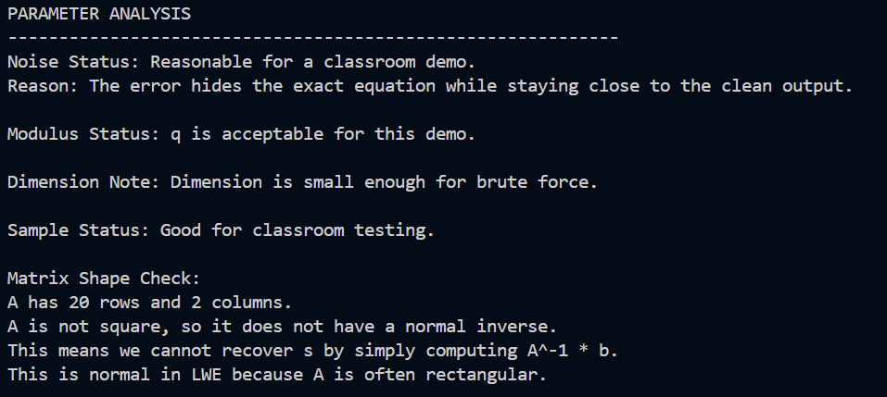
- The modulus controls the range of integers valid for this system.
- The dimension controls the size of the hidden secret.
- The number of samples determines how many public equations are generated.
- The noise controls how much the equation is perturbed.

Attack Results
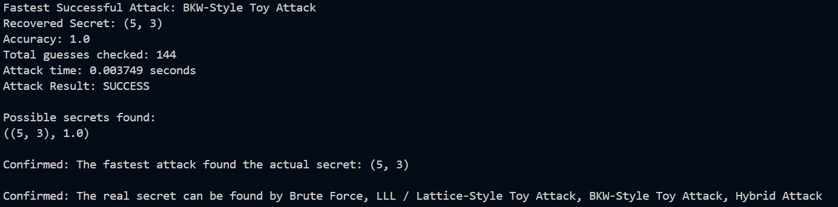
The brute-force attack succeeds since the search space is intentionally tiny.
Real lattice-based cryptography uses parameter sizes that make this type of exhaustive search computationally infeasible.
The attack exists only to demonstrate how parameter selection affects computational difficulty.

Part 3B – Understanding Graphs

Graph 1 – lwe_scatter_plot.png
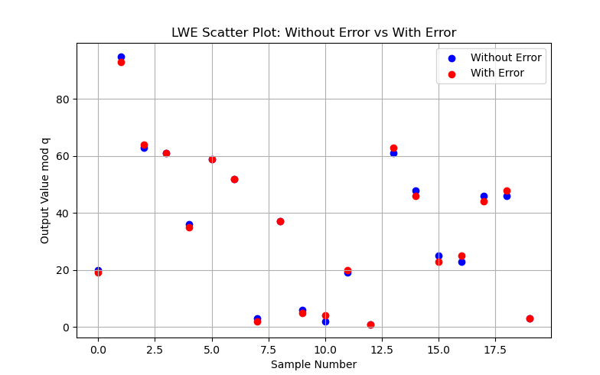
Explain
- Blue points represent outputs before adding error.
- Red points represent outputs after adding error.
- Each pair of points corresponds to the same equation.
- The red points remain close to the blue points but rarely identical.
Conclude:
The random error changes each equation only slightly while preserving the overall structure.

Graph 2 – lwe_clean_vs_noisy.png
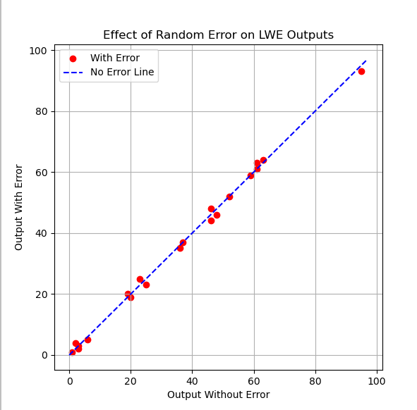
Explain:
- Each point compares one clean output with its corresponding noisy output.
- The dashed blue line represents the ideal case where no error has been added.
- If there were no errors, every point would lie exactly on this line.
- Because small random errors are added, the points remain close to, but not exactly on the line.
Conclude:
The error changes the outputs just enough to hide the exact mathematical relationship while preserving the overall behavior of the system.

Part 5 – Student Worksheet Activity
Students can now complete the worksheet.
The worksheet is intended to reinforce the demonstration and not replace it.
Students should:
- Record the values produced by default run.
- Compare clean and noisy outputs.
- Analyze the scatter plot.
- Analyze the line plot.
- Compare: Output table, Scatter plot, Line plot, Attack results.

Part 6 – Guided Discussion
Lead the class using questions like:
- What happens when the noise is removed completely?
- Why does the noisy output remain close to the clean outputs?
- Why does not increasing noise indefinitely improve security?
- Why do most cryptographic systems balance security with reliability?
- Which graph best illustrates the effect of random error? Why?
- Based on today’s activity, why is random error useful in post-quantum cryptography?

Expected Student Takeaways
After completing the lesson, students should understand that Learning With Errors combines modular arithmetic, matrices, vectors, and carefully controlled random errors to create a mathematical problem that is easy to compute but difficult to reverse. Through the SageMath demonstration and graphical analysis, students should recognize that noisy outputs remain close to the clean outputs while obscuring the exact relationship needed to recover the secret. This balance between mathematical structure and controlled randomness is one of the key ideas underlying modern lattice-based post-quantum cryptography and serves as the conceptual foundation for many standardized post-quantum cryptographic systems.

